

**ChemXplosion Bio:**

ChemXplosion is a chemistry game which focuses on chemical reactions. The game was made in collaboration with our client, Thomas Gluick (seen below), a chemistry professor at GGC. The purpose of the game is to provide an entertaining and educational approach to chemistry. Our goal was to create a solid basis for future members to come in and work on, eventually reaching our main objective and creating something used in classrooms throughout GGC and beyond!



**Current and Future Features:**

Currently we have most of the main game done. The game starts with a main menu that includes a start button that starts the game, a help button that includes the user instructions for the game, an options button for adjusting game settings and lastly the exit button which exits the application. The options need to be actually set to tweak settings, but the UI is already set for it. Basic functionalities of starting the game and exiting application, however, work fully.

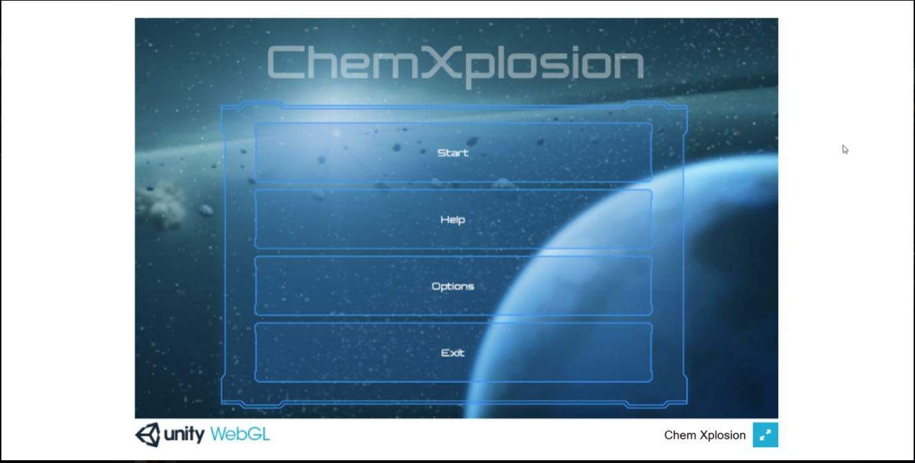

There is also a fully functional pause menu. The settings affect the look and feel of the game but need some tweaking. It allows for the adjustment of various options as well as restarting or exiting the game.

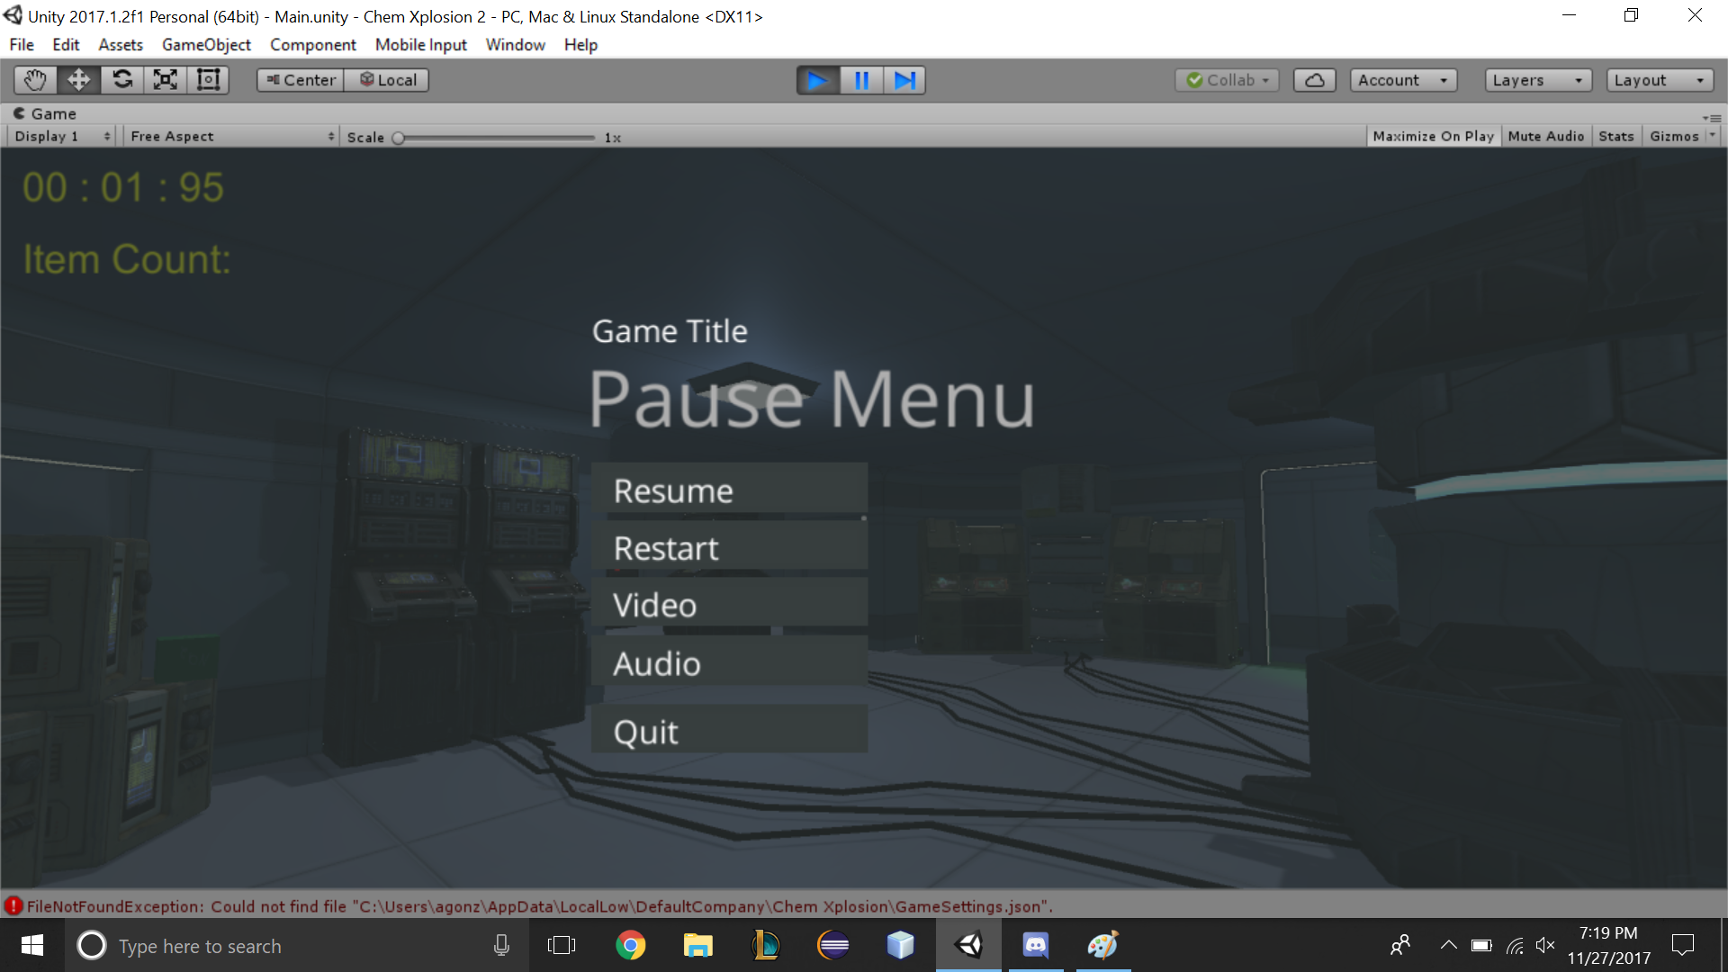

Puzzle 1 and Puzzle 2 are finished while 3 still needs to be added. Puzzle 2 also needs some texture work but the functionality is there. If you look below you can see the various screenshots of each puzzle from 1 to 3 respectively.

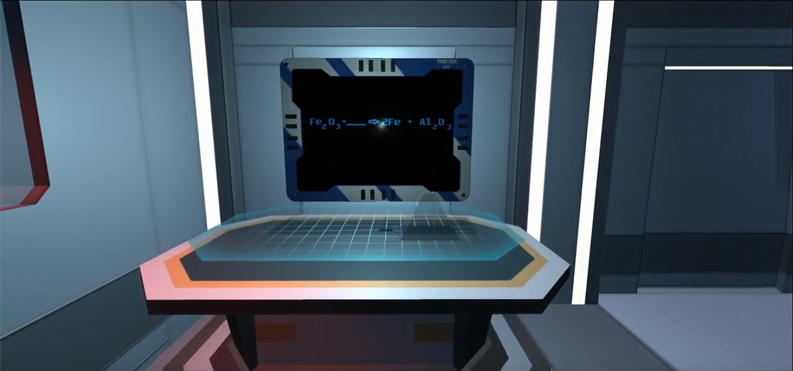

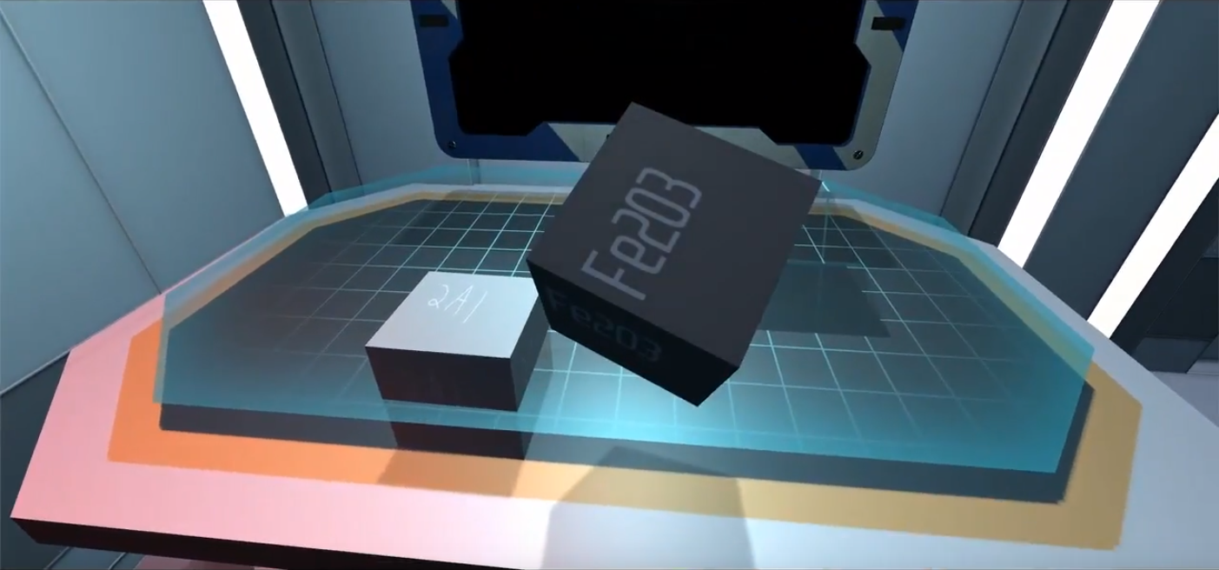

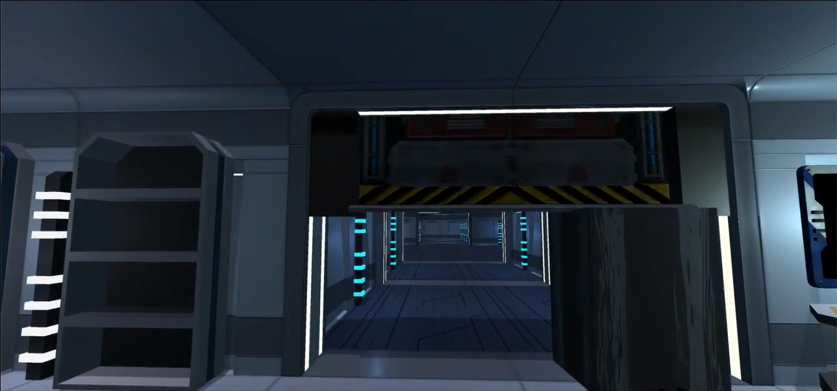

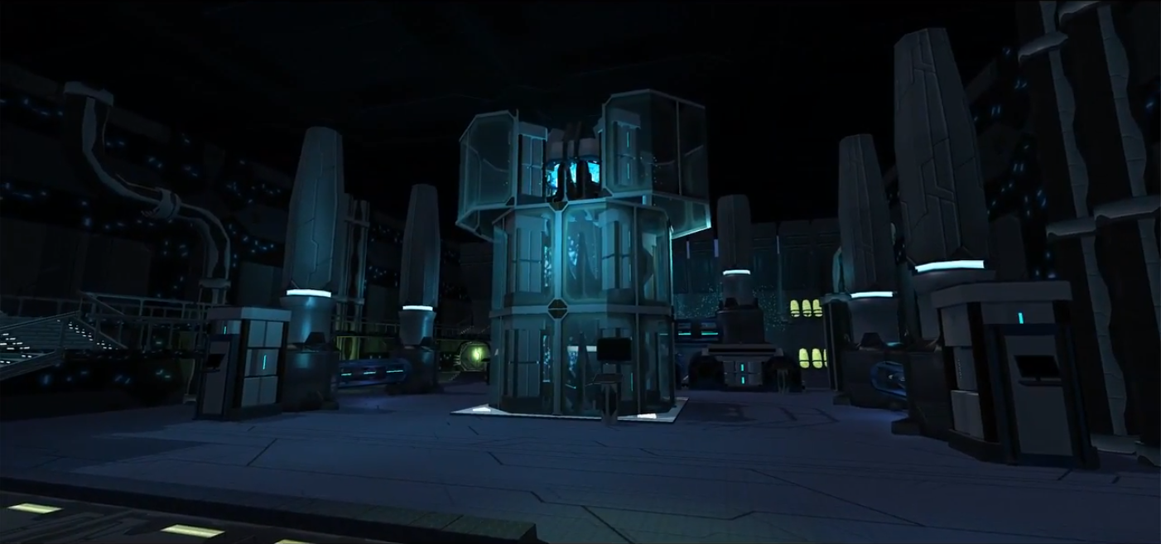

Puzzle 3 will need to be fully implemented but the foundation is already laid out. The overall game can be viewed through the falling screencast: [ChemXplosion Trailer #1](https://www.youtube.com/watch?v=T6DWbuIMuR8). There are few known bug issues that need to be worked out such as wall collisions that need to be worked out but overall the complete foundation has been laid out. The game will be launched through WebGL through the github repository and will require no downloads, while the user manual and instructions can be found within the actual game through the help menu.

**Tech-Challenged Group Photo:**

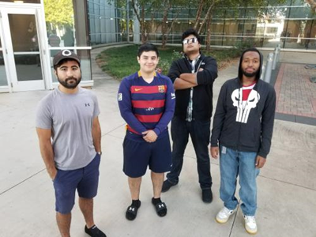

From left to right:

* Brendon Serrano:
  + Documentation Lead
  + UI/UX Designer
* Armando Gonzalez:
  + Testing Lead
  + Database Manager
* Anjan Panchatcharam:
  + Programming Lead
  + UI/UX Designer
  + Tester
* Eric Jenkins:
  + Team Manager
  + Client Liaison
  + UI/UX Lead Designer

**Survey Results:**

During CREATE we asked people to complete a survey after they got a chance to play the game to acquire feedback on what should be improved in the future and if the current direction of the game was well received. The results were as followed:

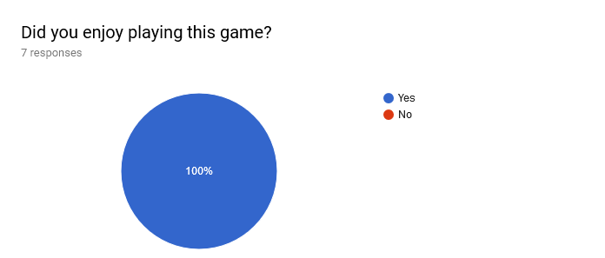

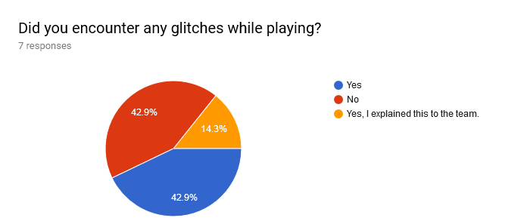

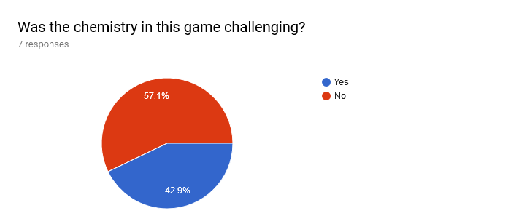

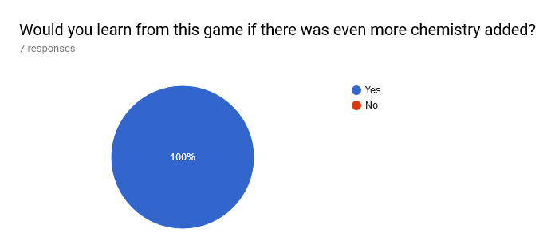

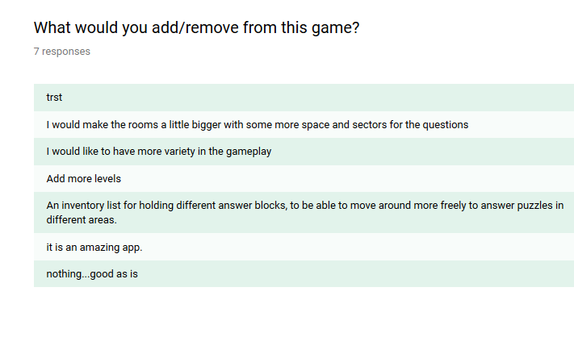

The feedback suggests that there is more work to be done but that people are indeed happy with the direction it is going. In the future we had hoped that player avatars, more levels and puzzles and overall more polish would be added to the game. The Tech Challenged team hopes that in the future, the next set of members manage to build on what we’ve started and create a game that students can learn from and enjoy!